Task 4 OLAP operations

1. Database creation

CREATE TABLE sales_sample (

Product_Id INTEGER PRIMARY KEY,

Region VARCHAR(50),

Date DATE,

Sales_Amount NUMERIC

);

–2.data creation

INSERT INTO sales_sample (Product_Id, Region, Date, Sales_Amount) VALUES

(11, 'East', '2024-04-11', 1600),

(12, 'West', '2024-04-12', 1900),

(13, 'North', '2024-04-13', 2100),

(14, 'South', '2024-04-14', 2300),

(15, 'Central', '2024-04-15', 1800),

(16, 'East', '2024-04-16', 2000),

(17, 'West', '2024-04-17', 2200),

(18, 'North', '2024-04-18', 2400),

(19, 'South', '2024-04-19', 1700),

(20, 'Central', '2024-04-20', 1900);

/*3.perform OLAP operations

1. Drill down*/

SELECT

Region,

Product_Id,

SUM(Sales_Amount) AS Total_Sales

FROM

sales_sample

GROUP BY

Region,

Product_Id

ORDER BY

Region,

Product_Id;

–B. Rollup

SELECT

CASE

WHEN Product_Id IS NULL THEN 'Total'

ELSE Region

END AS Region,

Product_Id,

SUM(Sales_Amount) AS Total_Sales

FROM

sales_sample

GROUP BY

ROLLUP (Region, Product_Id)

ORDER BY

Region,

Product_Id;

–C.cube

GROUP BY CUBE (Product_Id, Region, Date) ORDER BY Product_Id, Region, DateSELECT CASE WHEN Product_Id IS NULL AND Region IS NULL AND Date IS NULL THEN 'Total'

WHEN Product_Id IS NULL AND Region IS NULL THEN 'Total by Date'

WHEN Product_Id IS NULL AND Date IS NULL THEN 'Total by Region'

WHEN Region IS NULL AND Date IS NULL THEN 'Total by Product'

WHEN Product_Id IS NULL THEN 'Total by Region, Date'

WHEN Region IS NULL THEN 'Total by Product, Date'

WHEN Date IS NULL THEN 'Total by Product, Region'

ELSE 'Detail'

END AS Perspective,Product_Id,Region,Date, SUM(Sales_Amount) AS total_sales FROM sales_sample

;

–D.slice

Select * From Sales_sample Where Region = 'East' and Date Between '2024-04-01' and '2024-10-10'

–E.dice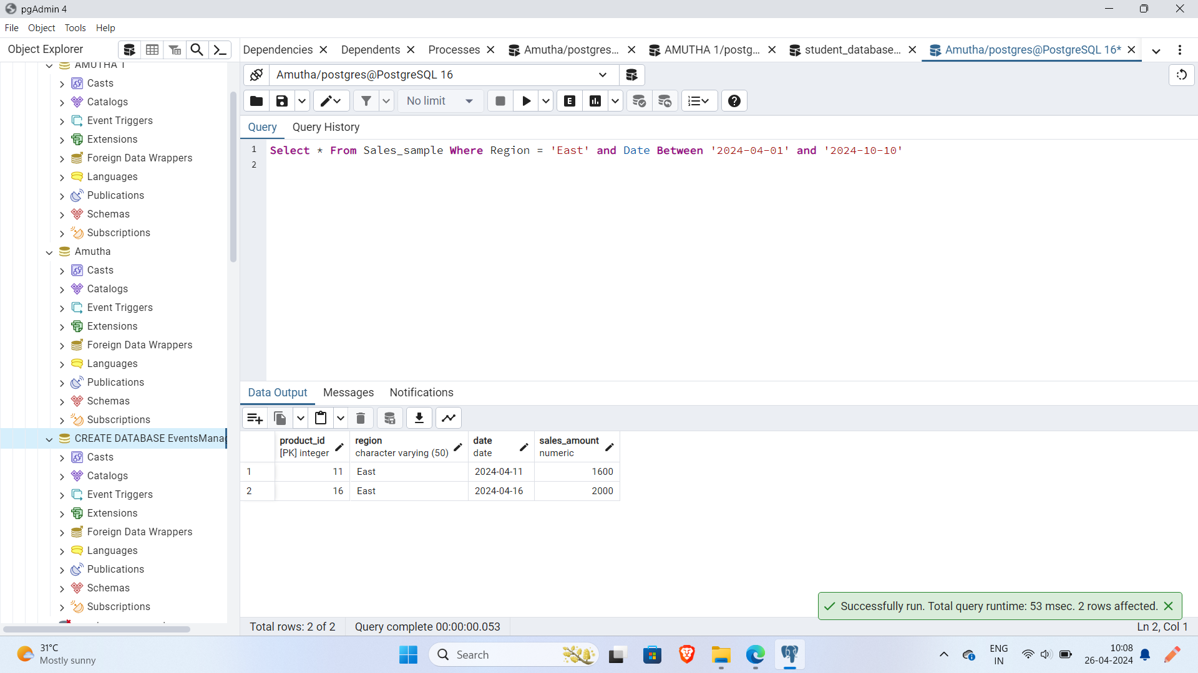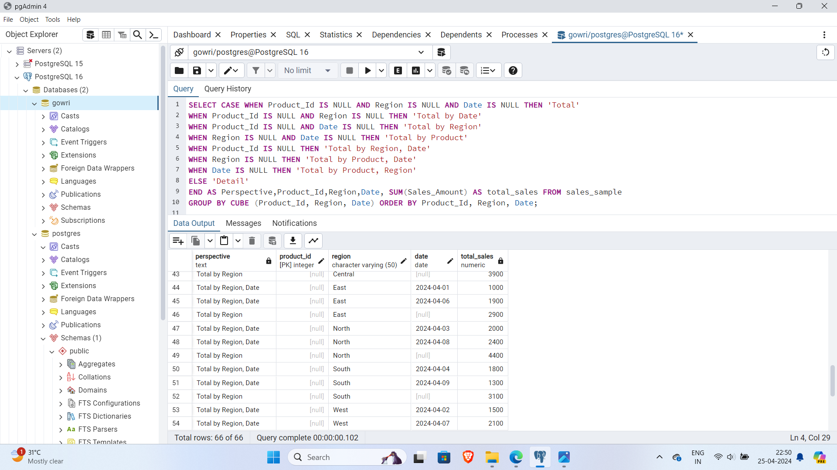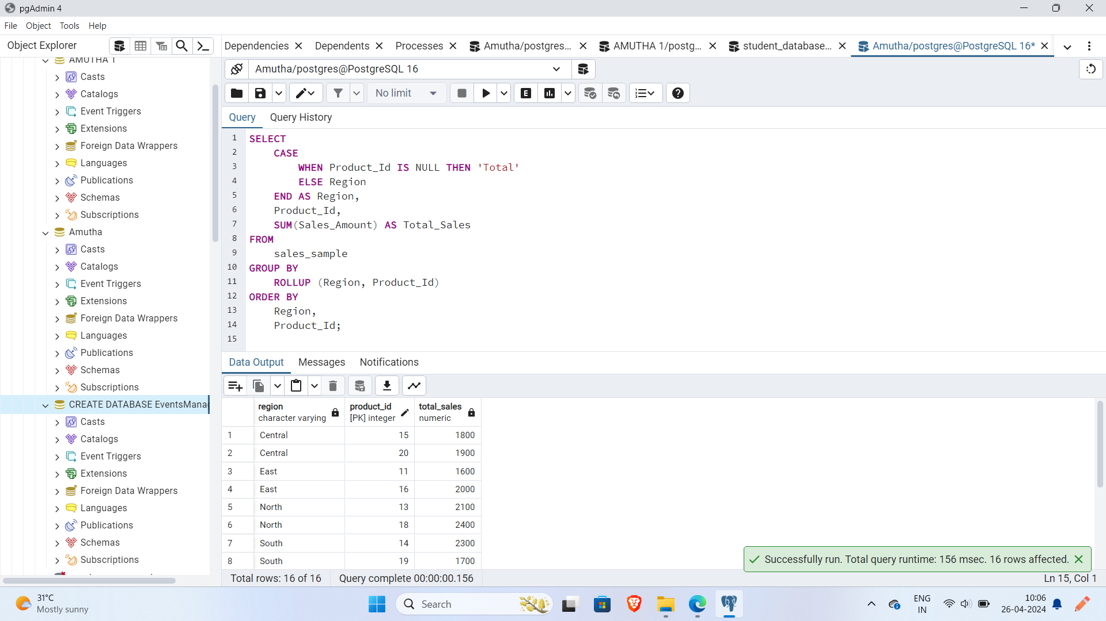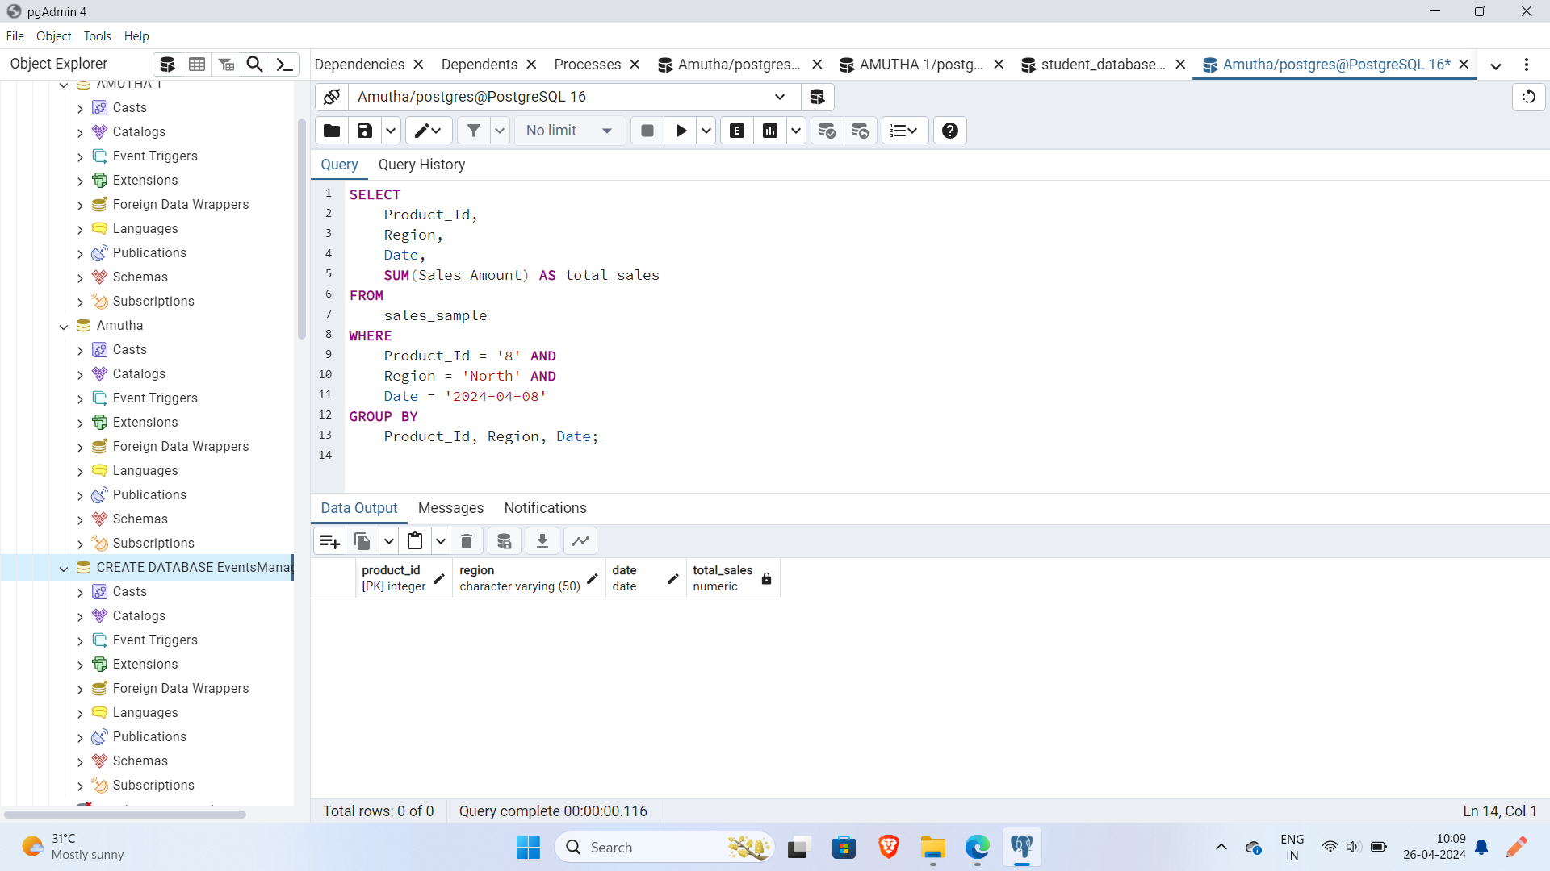

SELECT

Product_Id,

Region,

Date,

SUM(Sales_Amount) AS total_sales

FROM

sales_sample

WHERE

Product_Id = '8' AND

Region = 'North' AND

Date = '2024-04-08'

GROUP BY

Product_Id, Region, Date;